Protocol

*Aim*

Does gamification improves student’s experience and outcomes of learning the effects between traits in a public health intervention simulator?

*Objectives*

Hypotheses (Primary objectives)

* Gameplay will improve learning outcomes compared to a non-gamified control
* Gameplay will motivate players to engage with learning materials for longer compared to a non-gamified control
* Gameplay will structure players engagement with learning materials by directing their interactions more compared to a non-gamified control

Exploratory questions (Secondary objectives)

* How do specific game mechanisms modify the learner experience?
* What are the choices that players make about public health interventions? And how does this compare to mathematically optimal choices?

*Data collection*

Participants will be directed to complete an online form where they will be redirected to either a game or interactive visualisation and instructed to use this to learn about the effects of public health interventions. Participants are instructed to use this until they feel they have an understanding of the data.

Software usage measures

While participants use the interactive visualisation and game two pieces of information will be collected:

* The length for which participants use the interactive visualisation / game
* The interventions participants make using the software (see below for snip-it)

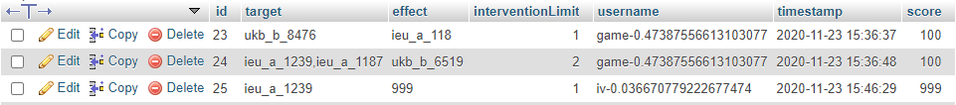

*This figure illustrates that the interventions participants make is stored in a spreadsheet type database with the following information: the goal they were trying to achieve, the intervention(s) they made on traits to achieve it, the effectiveness of their intervention, and an anonymous session identification number randomly generated for each user (to make within-subject inferences)*

User experience questionnaire

Participants then complete a user experience questionnaire involving three questions:

* Please indicate your agreement: I felt motivated to make interventions using the software
* Please indicate your agreement: I felt guided in making interventions using the software
* Identify whether you experienced each of 22 categories of PLayful EXperiences (PLEX inventory, see below for snip-it)

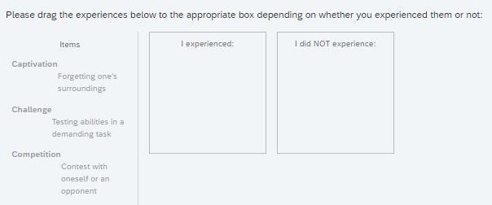

Assessment

Participants then complete an open-book assessment of learning outcomes, with a copy of the interactive visualisation for reference:

* 25 questions directly assessing individual identified learning outcomes
  + Scoring: Sum of the number of questions they answered correctly (25 pts)
* 4 intervention design scenarios where participants design interventions to achieve goals
  + Scoring: How much their intervention achieved the optimal result (4 pts)
    - The results of every possible intervention are found using a propagation algorithm
    - The optimal intervention is defined as the intervention which achieves the greatest beneficial increase in the goal trait’ prevalence (e.g., reducing smoking by 20 cigarettes/day)
    - Participants are scored by how much their intervention achieved the effect that the optimal intervention did (e.g., an intervention which reduces smoking by 10 cigarettes/day would be 50% efficient compared to the optimal and receive a score of 0.5
* Participants will be timed for how quickly they complete this assessment

*Analysis plans*

The hypothesis ‘Gameplay will improve learning outcomes compared to a non-gamified control’ will be rejected if BOTH:

* + - a t-test comparing participants scores between groups returns no significant difference (alpha level = 0.05)
    - a further t-test returns no significant difference in the time it takes participants to complete the assessment

The hypothesis ‘Gameplay will motivate players to engage with learning materials for longer compared to a non-gamified control’ will be rejected if BOTH:

* + - a t-test comparing participants Likert responses to the item ‘I felt motivated…’ between groups returns no significant difference
    - a further t-test returns no significant difference in the time participants use the software for

The hypothesis ‘Gameplay will structure players engagement with learning materials by directing their interactions more compared to a non-gamified control’ will be rejected if:

* + - a t-test comparing participants Likert responses to the item ‘I felt directed…’ between groups returns no significant difference

*Exploratory questions*

How do specific game mechanisms modify the learner experience?

* + - Explored by: Comparing the experiences participants reported feeling (PLEX) to see if the game led to feelings of ‘competition’ or ‘thrill’ for example

What are the choices that players make about public health interventions? And how does this compare to mathematically optimal choices?

* + - Explored by: Comparing participant’s policies they enact using the interactive visualisation and game to the mathematically optimal policies, and observing any trends in the types of traits participants choose to intervene on